Task: Working safely in vehicles during COVID-19 | Facility: Enter your site name here | Issue No: 1

This template must be edited to cover your site. The purpose of this risk assessment is to ensure the safely of workers who are working in or from a vehicle during the coronavirus pandemic.
Assessed by: Mark Shakespeare-Fletcher, Graham READ, ANDY Milverton |  |  | Approved by:
Assessment date: 11/05/2020 |  |  | Review Date: At the COVID-19 Review meeting Weekly or when government guidance changes  Review not to exceed 2 years from assessment date
Record Significant Hazards | Person(s) at Risk | Existing Control Measures  (ECM) | Initial  Risk Rating  With ECM |  |  | Additional Control Measures (ACM) | Residual  Risk Rating  With ACM |  |  | Additional  Information
 |  |  | S | L | R |  | S | L | R
Provide specific details. E.g. ‘work at height” say how high. E.g. “Electricity” state voltage and type of hazard, Striking underground services | Who might be harmed and how E.g. “Contractor or Employee Fall from 2.0 metres” | Detail existing control measures.  These are the controls that are currently in place | S – Severity  L – Likelihood  R - Risk |  |  | Detail additional control measures needed to eliminate hazard completely or minimise risk to acceptable level.  (Include in Site Action Plan) | S – Severity  L – Likelihood  R - Risk |  |  | Cross Reference & Additional  Information e.g. SOP, COSHH Assessment
Biological  Coronavirus and the disease it causes, COVID-19 | 1. Thinking about risk  Employees  and their Families  Contractors | COVID-19 risk assessments for offices have been carried out  The following control measures and other information, which will help employees and their families to protect their health are communicated to employees via email bulletins and are posted on the HomeSafe-Me website:  - Wash your hands regularly with soap and water, or clean them with alcohol-based hand rub  - Maintain at least 2 metre distance between you and others  - Avoid touching your face  - Cover your mouth and nose when coughing or sneezing  - Stay home if you feel unwell  Regular coronavirus updates are emailed to all employees  Documents are produced in a number of languages to ensure effective communication with employees, whose first language is not English |  |  |  | Share this risk assessment with the workforce  Erect the HM Government poster, Staying COVID-19 Secure in 2020, in each workplace and place a sticker in all vehicles which are used to carry out work in or from  N.B. this is included in the managers pack and stickers can be sourced via the signage catalogue  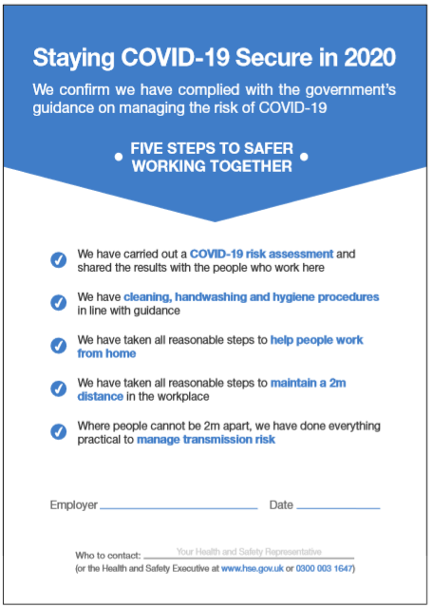  HSSA managers should work with the communications team to produce a communication, to be issued to clients / contractors, which will set out the measures we have taken to create and maintain a safe working environment, and which highlights their responsibilities within this and any safety rules, which may have changed |  |  |  | Staying COVID-19 Secure in 2020 stickers may be ordered from GK signs. The signage catalogue is included in the managers information pack of documents
Biological  Coronavirus and the disease it causes, COVID-19 | 2. Who should go to work | Where a person can effectively carry out their work from home, they should continue to do so.  Only essential work from and in vehicles is permitted  Occupational health team in place to provide guidance and support on health-related matters to returning employees  Employee assistance package in place, which can be accessed by all employees to source mental health and wellbeing guidance and support. This ranges from downloadable materials, to telephone support and face to face counselling  HomeSafe E-learning module 5 – Mental Wellbeing – is ready for all employees to complete  Health advice is provided on the HomeSafe-Me website: https://www.homesafe-me.co.uk/coronavirus/general-advice/health-and-wellbeing/ |  |  |  |  |  |  |  | Workplace Wellness, is a free, confidential service provided by Pennon to all employees. You are able to access expert advice, invaluable information, specialist counselling and support 24 hours a day, 7 days a week, online or on the phone.  For South West Water employees: Confidential telephone helpline: 0800 1116 387  Online self-help EAP portal: www.my-eap.com  Website access code: SWWLwell  For Viridor employees:  Confidential telephone helpline: Freephone - 0800 111 6387  From outside the UK:+44 845 330 5132(Calls will be charged but call-back can be requested)  Website:www.my-eap.com  Organisation code: VWMLwell​
Biological  Coronavirus and the disease it causes, COVID-19 | 3. Social distancing  Employees  Visitors  Contractors  Employees’ Families | In an accident or emergency situation employees do not need to stay 2 metres apart if it would be unsafe to do so  People who offer assistance in an emergency situation, such as first aid or rescue, should carry out effective handwashing for at least 20 seconds, once safe to do so  Where possible all work from or in vehicles is carried out with only 1 person per vehicle  Where possible vehicles are not be shared between different users  Where 1 person per vehicle is not possible, frequent touch points in and on the vehicle must be cleaned between each user – information on vehicle cleaning is included in the cleaning section of this risk assessment  Where it is necessary for more than one person to travel in a vehicle, social distancing should be maintained  Where possible the driver should not interact with people on site when loading / unloading the vehicle  Unnecessary contact at gatehouses, security or weighbridges and in the yard must be minimised as far as practicable.  Welfare facilities provided on site  Social distancing must be maintained when using welfare facilities  Drivers must stay in their vehicles, where this does not compromise safety and safe working practices  Where drivers cannot stay in their vehicles for safety reasons, they must comply with the site risk assessment and safe operating procedures |  |  |  | Where possible reduce the numbers of drivers arriving at or leaving from the base site at any one time  Where possible schedule delivery / pick up times for times when the site will not be overcrowded and, if possible, avoid rush hours  Investigate alternatives to two or more people working in or from a vehicle  Develop and communicate a seating plan for each class of vehicle, which identifies where occupants should sit to maintain social distancing  Where social distancing in vehicles is not possible and people are seated or working within 2 metres, the following mitigations should be considered:  - Make sure vehicles are well ventilated. If necessary, keep windows open wide enough to maintain a flow of fresh air within the seating area of the vehicle  - Erect clear signage to outline the social distancing measures in place, for example the seating plan  - If passengers need to sit close together sit side by side, rather than face to face  - Where possible and where it does not compromise safety, consider installing screening  - Consider the use of face coverings  Consider the use of electronic paperwork where possible  Review on site procedures to ensure safe exchange of paper copies of documents
Biological  Coronavirus and the disease it causes, COVID-19 | 4. Customers, visitors and contactors  Employees  Employees’ Families Contractors  Visitors | Fare paying passengers are not carried in our vehicles  Non fare paying passengers, who are not employed by the company, are not carried in company vehicles
Biological  Coronavirus and the disease it causes, COVID-19 | 5. Cleaning  Employees  Contractors  Employees’ Families | An enhanced office cleaning regime has been implemented at base sites, where the users of vehicles will report for work  Posters are erected at base sites to build awareness of the importance of effective hand washing  Employees are advised to increase the frequency of handwashing throughout the day and particularly:  - Before boarding vehicles  - On return to their base site  - On return home  Hand protection is provided to all employees using vehicles  A template risk assessment for the cleaning of vehicles, suspected to be contaminated with coronavirus, has been produced and implemented  Guidance on the cleaning of vehicles suspected to be contaminated with coronavirus has been produced and issued  A Home Safe toolbox talk on how to clean your vehicle has been produced for delivery to all relevant employees  Employees using a vehicle to travel to work or for their work duties must clean their vehicles after use.  N.B. Particular care should be taken to sanitise hand contact areas, such as the door handle, steering wheel, gear stick etc.  Users must ensure regular cleaning of vehicles, in particular the hand contact areas, between users  Waste items must be removed from the vehicle whenever possible throughout the shift  All waste items and personal belongings must be removed from vehicles at the end of each shift  The number of workers allowed into the office building is reduced to allow social distancing to be operated  Visitors to the base site are prohibited or kept to a minimum  Where it is not practicable to prohibit visitors, all visitors must sign in and receive a site induction. The site rules on social distancing and hand hygiene must then be explained to them prior to allowing entry |  |  |  | If showering takes place when drivers return to site, set clear guidance for the use of the facilities, including the requirement to keep lockers clean, remove waste and personal belongings and to practice social distancing  The manager / supervisor should assess how those workers, working in or from a vehicle can achieve more frequent handwashing and provide information / materials to allow this to happen  Provide sanitising gel / wipes in vehicles to allow workers to regularly clean their hands and the frequent hand contact areas in and on their vehicle  Consider the provision of individual cleaning kits for drivers, consisting of alcohol gel, sanitary wipes and a disposal bag, to allow employees to clean and disinfect the frequent hand contact points in and on their vehicle, before use  Ensure that drivers have access to appropriate toilet facilities during their journeys |  |  |  | Posters may be printed from the .pdf files which are included in the managers information pack of documents  HomeSafe toolbox talk – Vehicle cleanliness to reduce the risk of coronavirus transmission:  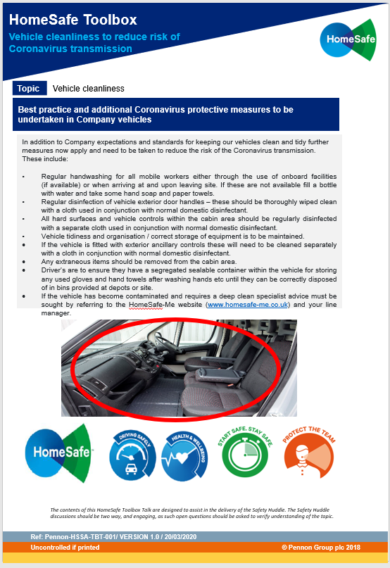
Biological  Coronavirus and the disease it causes, COVID-19 | 6. Personal protective equipment (PPE)  Employees  Contractors  Employees’ Families | Five items of PPE must be worn when carrying out work duties:  - Hand protection  - Head Protection  - Eye Protection  - Foot Protection  - High Visibility Jacket  Additional PPE, identified by the risk assessment for the tasks being carried out, must also be worn  Where social distancing in vehicles cannot be achieved, face coverings are provided |  |  |  | If face coverings are to be used:  - Ensure that they do not impede the driver’s vision  - Consideration should be given to ensuring more frequent breaks are taken  - Avoid touching your face or face covering, as you could contaminate them with germs from your hands  - Change your face covering if it becomes damp or if you’ve touched it  - Continue to wash your hands regularly  - Change and wash your face covering daily  - If the material is washable, wash it in line with the manufacturer’s instructions
Biological  Coronavirus and the disease it causes, COVID-19 | 7. Workforce management  Employees  Contractors  Employees’ Families | At risk, vulnerable, employees have been identified and are logged with the occupational health team  At risk, vulnerable, employees have been identified and are supported to work from home  Drivers and teams are not required to stay away from home for work related matters  When visiting company or client sites person to person contact must not take place and social distancing must be maintained  A process is in place for employee / union consultation  Daily safety briefings take place  A safety cross is displayed on each base site |  |  |  | Where a team of two or more workers are required to regularly carry out work in or from vehicles, consider forming them into fixed teams. This will help to minimise their contact with others and ensure that any unavoidable contact between the team happens between the same people  Where possible, fix the pairings of people using the same vehicle  Identify areas where people have to directly pass items to each other and develop controls to ensure that direct contact is prevented or kept to a minimum
Biological  Coronavirus and the disease it causes, COVID-19 | 8. Inbound and outbound goods  Employees  Contractors  Employees’ Families | Non business (personal) deliveries to the site are prohibited  A risk assessment is in place for cleaning vehicles |  |  |  | Revise pick up and drop off collection points to allow social distancing or minimise the risk of contact with others

RISK RATING TABLE |  | Probability / Likelihood |  |  |  |  |  |  | Guidance Notes
 |  | Highly Unlikely | Unlikely | Possible | Likely | Very Likely
 |  | May occur in exceptional circumstances, so could happen but probably never will | Not expected, but slight possibility it may occur at some time | The event might occur at some time as there is a history of infrequent occurrence within the company | There is a strong possibility the event will occur as there is a history of frequent occurrence within the company | It is almost certain the event will occur | People, Employees or Third Parties | Property, Process, Machinery or Equipment | Environment | Vehicle
Severity |  | 1 | 2 | 3 | 4 | 5
No injury / no damage | 1 | 1 | 2 | 3 | 4 | 5 | No first aid required | Non-serious. No equipment or facility damage | Chemical spill, release or emission, contained and only minor clean up. No external reporting required. | No injury caused by vehicle  No damage to vehicle  No damage caused by vehicle
Minor injury, cuts, abrasions, burns / minor damage | 2 | 2 | 4 | 6 | 8 | 10 | First aid only | Minor subsystem loss and/or moderate facility damage | Chemical spill, release or emissions, requiring only minor clean up and no external reporting required | Minor injury caused by vehicle  Minor damage to vehicle  Minor damage caused by vehicle
Injury requiring hospital or doctors attention. Injury resulting in lost time | 3 | 3 | 6 | 9 | 12 | 15 | Medical treatment or restricted work activity. Short term occupational illness. | Moderate system loss and/or moderate facility damage. | Chemical spill, release or emission which requires limited on-site clean-up and/or external reporting. | Injury requiring hospital treatment caused by vehicle  Moderate damage to vehicle  Moderate damage caused by vehicle
Major injury, fracture, dislocation, amputation. Disabling illness. Major damage | 4 | 4 | 8 | 12 | 16 | 20 | Lost time or temporary disability. Long term occupational illness. | Major subsystem loss and/or severe facility damage | Chemical spill, release or emission requiring major on site clean-up, temporary environmental or public health impact | Major injury caused by vehicle  Major damage to vehicle  Major damage caused by vehicle
Fatality | 5 | 5 | 10 | 15 | 20 | 25 | Fatality or major disability e.g. loss of limb | Complete system loss and/or extensive facility damage | Chemical spill, release or emission requiring off site clean-up or acute, lasting environmental or public health impact. | Fatal injury caused by vehicle  Major damage to several vehicles  Catastrophic damage caused by vehicle

RISK LEVEL / ACTION TABLE

Risk Rating | Risk Level | Action
15 – 25 | HIGH | Work should not be started or must stop immediately.  No work may recommence until risks have been reduced as far as reasonably practicable through the implementation of control measures
6 – 12 | MEDIUM | Risks must be further reduced if reasonably practicable
1 - 5 | LOW | Acceptable – keep under review

The level of the risk rating determines the action required, as demonstrated below.

